CREATING DATABASE ‘custom’:



SHOW DATABASE AND USE DATABASE ‘custom’:

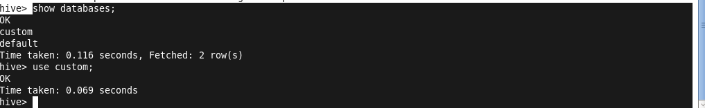

CREATE TABLE ‘temperature_data’:



LOADING THE FILE ‘dataset.txt’ INTO THE TABLE ‘temperature_data’ WHICH IS DELIMITED BY ‘,’:



DISPLAYING THE DETAILS OF THE TABLE ‘temperature_data’:

